1. Run the initial project and do a screen print from the browser.

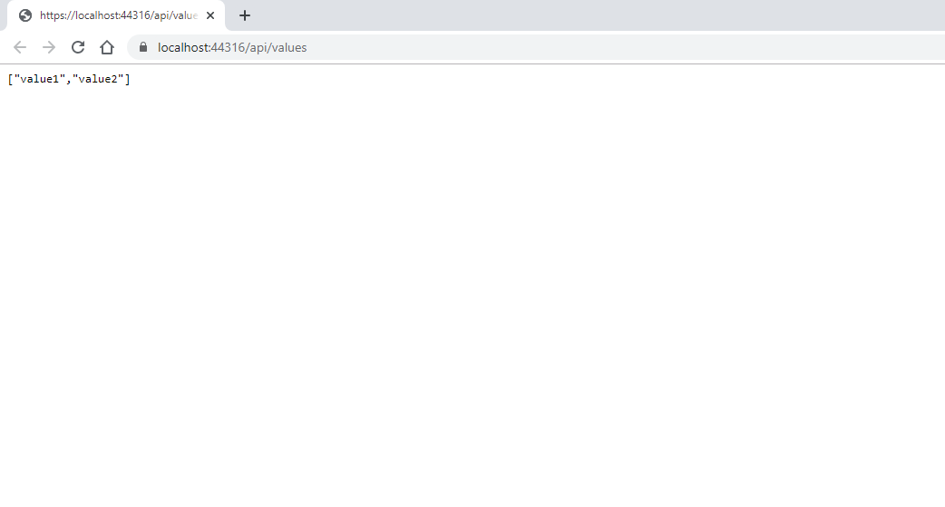

1. Copy and paste the block of code that generates the above response.
2. // GET: api/<controller>
3. [HttpGet]
4. public IEnumerable<string> Get()
5. {
6. return new string[] { "value1", "value2" };
7. }
8. // GET api/<controller>/5
9. [HttpGet("{id}")]
10. public string Get(int id)
11. {
12. return "value";
13. }
14. What is the format of the response from above?

JSON

1. True or False: Model classes must reside in the Models folder in order for the application to function properly.

True

1. What is the purpose of the Id property in Entity Framework?

To be a unique identifier to locate the data we have stored.

1. What class does the TodoContext class inherit from?

DbContext

1. What data type is used to store the to do items?
2. What element connects the TodoContext with the corresponding controller?
3. What file was updated to include the dependency injection for the TodoContext?

Startup.cs